Coursework Report

Zhao Yue

[40413819@napier.ac.uk](mailto:40413819@napier.ac.uk)

**Target**

Three weeks ago, when I knew that coursework can customize the theme, I thought of my favorite game--Don't Starve. Sometimes people want to watch some game videos or search for some game information, but they may can’t achieve their purpose on a web-app, so I want to create a page to integrate all of this, which is the direction my web application is trying to accomplish. Because of this reasons, my web-app name is called **WE Don't Starve**.

**Abstract**

In this coursework1, I have roughly determined his frame structure. And it can already implement a part of his functions, this includes four pages: Home, Characters, Log in, Development, and some features: Drop-down menu, Search bar, Table, Hyperlink, Image automatic loop display, Capsule tab, Navigation bar…But it still has a lot of features not implemented, is an unfinished page, but fortunately, I will finish it in coursework2.

**Introduction**

1. This is my main page – Home. I mainly introduce the basic information of the game on this page and use the list to display.

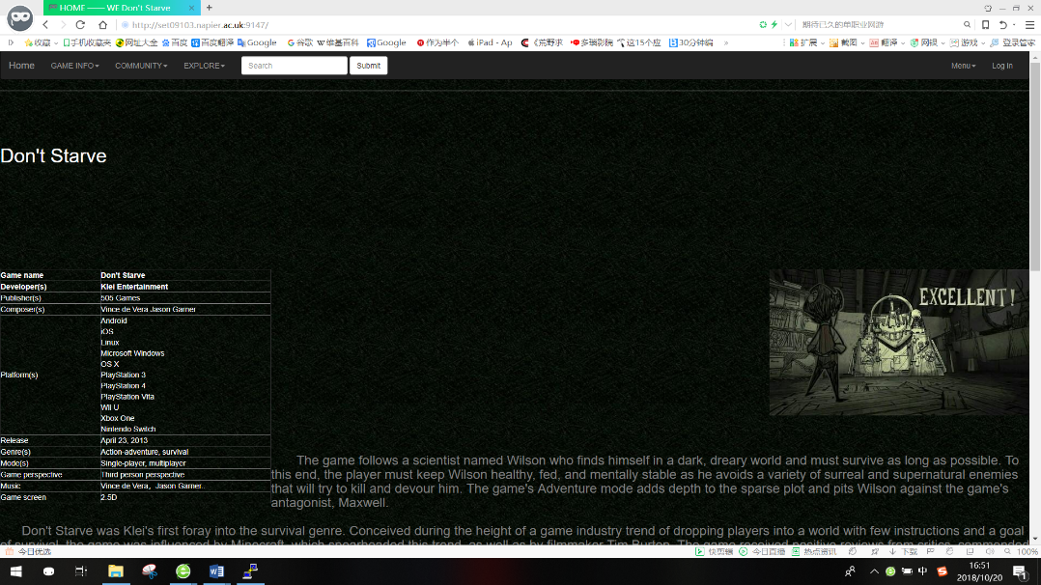

<Home1.1>

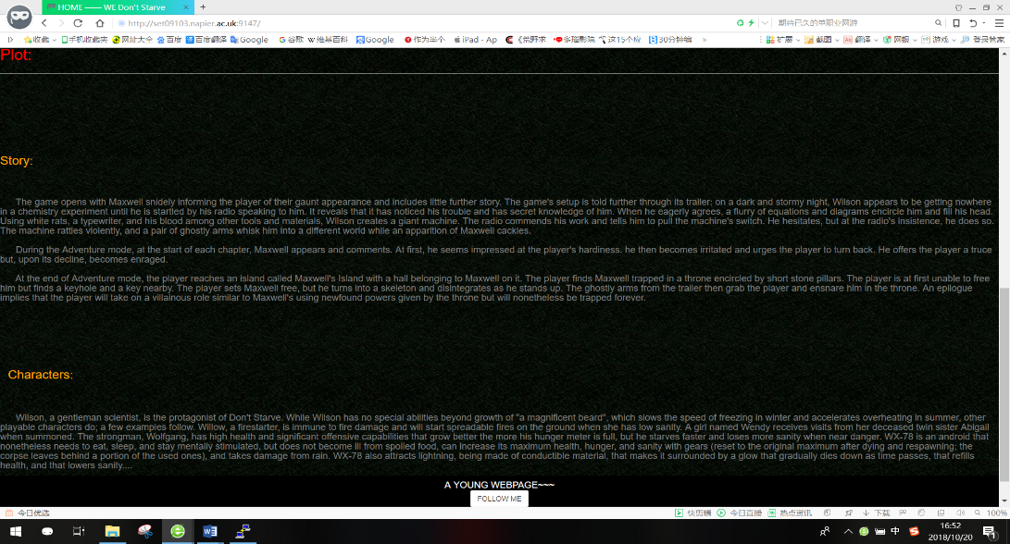

<Home1.2>

Just like the home button of an Apple phone, if you forgot which page you are on, in <Home2.1> you can see that there is a Home button here that makes it easy for you to get back to the main page.

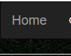 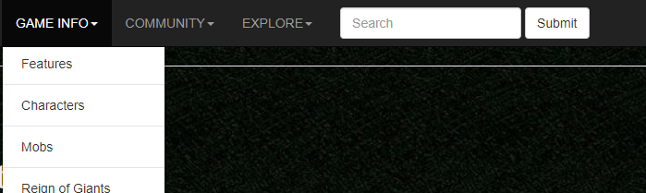

<Home2.1> <Home2.2>

In <Home2.2>, you can see the navigation bar in the header, where each drop-down menu can be implemented, all the buttons inside can implement the jump page, but because there are too many pages, I only made an example.

 In this search box, where people can search for what you want to search for.  This is the footer of all my pages.

 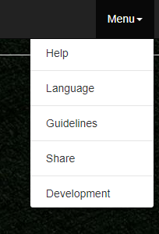 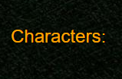

<log in> <development> <characters>

There are three buttons here: log in, development, characters, they can jump to the other three pages. On the **Log in** page, there is a login box that provides users with input user information, and I will also add a registration function in the subsequent coursework2.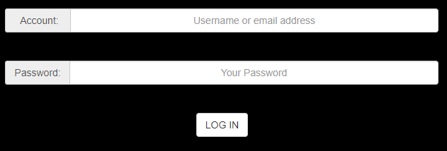 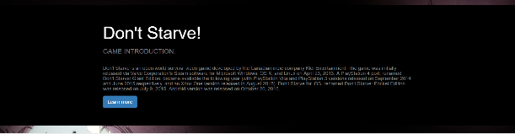

<log in page> <characters1.1>

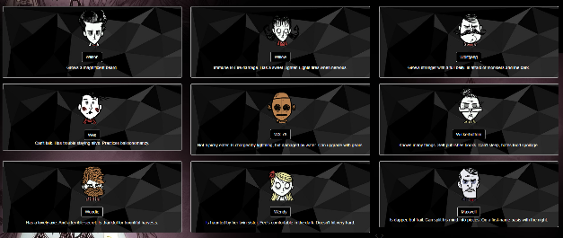 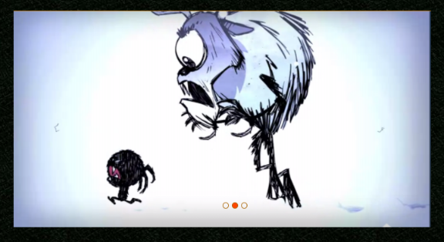

<characters1.2> <development1.1>

 

<development1.2> <characters1.3>

In <characters1.1>, this Giant screen shows more information of Don’t Starve besides the character information. But the page of the Learn more button has not been made yet. In <characters1.2>, this thumbnail feature shows the main content of this page, character brief, people can click on the person's name to see more details. In <characters1.3>, this is the page turning function make a page don't have to put too many things. I put an Image automatic loop display in <development1.1>, it loops every two seconds, but as a demo, I didn't put too many pictures in it. The last thing I want to say is the name of the web page. Just like in <development1.2>, the name of this page will be attached to the front of Don’t Starve.

**Design**

Log in

404

Python

(text.py)

Template page(base_pro)

Characters

Home

development

(Black line indicates running relationship, blue line indicates inheritance)

**Enhancements**

It can be said that my page still has a lot of hyperlink buttons that are not implemented, I have designed the hyperlink path and I will complete the remaining pages in coursework2. After the end of this coursework, I will continue to add a feature, that is, the pop-up function. I spent two days trying to add some dynamic elements and sliders within the page, but unfortunately I still can't achieve it, so I will learn how to complete it. In typesetting, I will add two static hover boxes on both sides of the page. I will continue to learn how to design a web page using flask and add other features during the learning process.

**Critical Evaluation**

I spent a lot of time designing on page layout. Finally, I chose to use thumbnails on the page to display, but what I don't understand is that although I have chosen to be centered and the code is working fine, there are some expected features that still don't work well, and sometimes his page display is not stable. Another shortcoming that I have done is Image automatic loop display has chosen to be centered, but there will be an offset when scaling the page size. And some of my features are not implemented, although this part of the code is already in html. I thought it may be the cause of code conflicts. Other parts that have been implemented, I think the completion is good. And the part of the flask that I just learned is running perfectly.

**Personal Evalation**

In this lesson, I learned how to use the vim editor, as well as using python, flask. The code I want to run should contain all the python code which I have learned and I did it. I tried to gradually replace some of the features in html with python. But since I haven't learned python in China, so I have encountered many difficulties in learning python. When I was studying the workbook, I encountered some difficulties. I asked my classmates and teachers, but most of them were solved by checking the information online. Now, I have completed the study on the workbook. The challenges I faced is language issues and the use of databases.

**References**

In the process of learning to design a web page, I checked a lot of information., I read the tutorial for this code and learned it. But on the Bootstrap, there is some code I have no ability to completely modify, I modified some of them. Below are the css, js files and some code I am using.

Css: bootstrap.min.css

Js: jquery-3.3.1.min.js, js/bootstrap.min.js

Code:

< Navigation >:

<nav class="navbar navbar-inverse">

<div class="container-fluid">

<div class="navbar-header">

<button type="button" class="navbar-toggle collapsed" data-toggle="collapse" data-target="#bs-example-navbar-collapse-1" aria-expanded="false">

<span class="sr-only">Toggle navigation</span>

<span class="icon-bar"></span>

……..

……..

……..(Add by myself)

<li class="dropdown">

<a href="#" class="dropdown-toggle" data-toggle="dropdown" role="button" aria-haspopup="true" aria-expanded="false">GAME INFO<span class="caret"></span></a><ul class="dropdown-menu">

<Input-group>:

<div class="row" style="text-align: center;">

<div class="col-sm-4 col-sm-offset-4">

<div class="input-group">

<span class="input-group-addon" id="basic-addon1"> </span>

<input type="text" class="form-control" placeholder="#" aria-describedby="basic-addon1" >

</div>

<div class="input-group">

<span class="input-group-addon" id="sizing-addon2">Password:</span>

<input type="text" class="form-control" placeholder="Your Password" aria-describedby="sizing-addon2">

</div>

<Pagination >:

<div class="row" >

<div class="btn-group" role="group" aria-label="...">

<button type="button" class="btn btn-default"></button>

</div></div>

<Picture>

<div class="col-md-4 col-md-4">

<div class="thumbnail" style="background-image: url(../static/characters.jpg);">

<img src="../static/willow.png" ><br>

………

………

………(Add by myself)

Picture:

<https://ss3.bdstatic.com/70cFv8Sh_Q1YnxGkpoWK1HF6hhy/it/u=561681045,2071914354&fm=26&gp=0.jpg>

<https://ss3.bdstatic.com/70cFv8Sh_Q1YnxGkpoWK1HF6hhy/it/u=2197274074,4188972777&fm=26&gp=0.jpg>

<https://ss1.bdstatic.com/70cFvXSh_Q1YnxGkpoWK1HF6hhy/it/u=3159566727,2434343954&fm=26&gp=0.jpg>

<http://zh.dontstarve.wikia.com/wiki/%E8%A7%92%E8%89%B2>

<https://ss1.bdstatic.com/70cFuXSh_Q1YnxGkpoWK1HF6hhy/it/u=1318324310,587206581&fm=26&gp=0.jpg>

<https://ss1.bdstatic.com/70cFuXSh_Q1YnxGkpoWK1HF6hhy/it/u=1925514376,1447297381&fm=26&gp=0.jpg>